

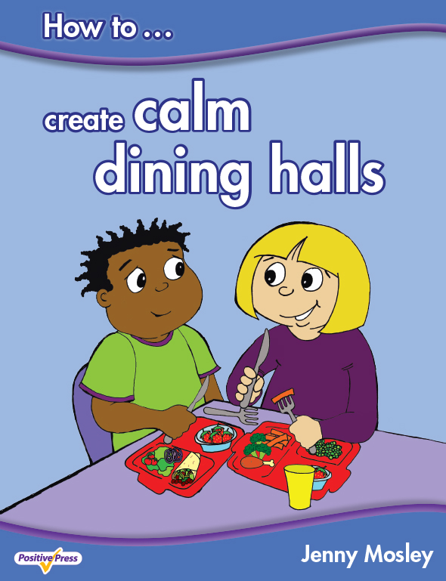
“Every part of the model has a positive impact on the school community and the successes achieved”
Fizz Starkey, ex Headteacher, NLE, SIP and Education Consultant

VIBRANT CIRCLE TIME FOR EARLY YEARS
Monday 20th March 2017
POWERFULLY POSITIVE LUNCHTIMES AND PLAYTIMES AND CALM DINING HALLS
Tuesday 21st March 2017
Moat Farm Infant School, Brookfields Road, Oldbury, West Midlands, B68 9QR

Conference Trainer – Jenny Mosley
Jenny Mosley is a national and international trainer and acclaimed founder of the Quality Circle-Time model. Jenny’s work and motivation has had an impact in thousands of schools. She wrote, for the DfE, the circle-time guidance for Early Years, Primary and Secondary SEAL. She also wrote the Happier Lunchtimes and Playtimes Guidance for the Primary National Strategy. She has published the first ever book on ‘How to Create Calm Dining Halls’. Find out how Jenny’s ideas support British Values and the latest guidance from Ofsted.

Vibrant Circle Time for Early Years – how to build young children’s emotional resilience, confidence and learning power Monday 20th March 2017 – 9am – 3pm
During the day jenny will work with a class of very young children to demonstrate the huge potential of circle time to support children, to develop social and emotional skills and values even in a very short time. Jenny will use puppets, games and speaking and listening activities and show how her Five Skills and Five Step model of circle-time is simple and straightforward – and can be used, with safe ground rules, by any enthusiastic early years’ practitioner
Powerfully Positive Lunchtimes and Playtimes and Calm Dining Halls
Tuesday 21st March 2017 – 9am – 3pm
This day will help your school create calmer dining halls and playgrounds. Jenny has hundreds of tried and tested ideas which can be immediately put into practice on your return. Unmissable for schools who have problems from lunchtimes which spill over into the afternoon affecting children’s learning and staff morale!
What past delegates say: “My head is buzzing with new ideas and I can’t wait to spread some joy! I would love everyone at my workplace to feel exactly the same as me! I feel absolutely motivated and how I felt when I first started this job 15 years ago!” Mim Slater, TA, Northborough Primary School
“Please thank Jenny…she is truly inspirational. Playtimes are now much improved, and we are working on all the issues, having fun and playing lots……” Louise Siriwetchaphan, Pupil Support Worker, Beechwood Primary School, Leeds
Who are these courses for: Teachers, TAs, Nursery Nurses, Childminders, Lunchtime Supervisors, all Early Years practitioners, Headteachers. Everyone!
TOP TIP!!! – Schools find it’s better to send different people on each day so you spread enthusiasm to all areas of the school!
Cost: £115 per day. Group bookings (4 and over) £95 per head per day (all plus VAT). Lunch and refreshments included.
Venue: MOAT FARM INFANT SCHOOL, BROOKFIELDS ROAD, OLDBURY, WEST MIDLANDS, B68 9QR
To book a place: Please complete attached application form and fax back to 01225 755631 or email to joannap@jennymosley.co.uk. or post to Jenny Mosley Consultancies, 28A Gloucester Road, Trowbridge, Wilts BA14 0AA. www.circle-time.co.uk. If you have any queries please contact Joanna on 01225 767157.

