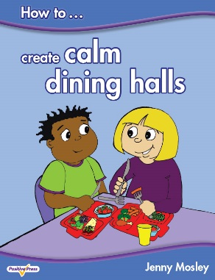

**BETTER BEHAVIOUR FOR LEARNING – PROMOTING POSITIVE RELATIONSHIPS THROUGH CIRCLE-TIME**

**Monday 13th February 2017**

**POWERFULLY POSITIVE LUNCHTIMES AND PLAYTIMES AND CALM DINING HALLS**

**Tuesday 14th February 2017**

**Betws Primary School, Betws Road, Bridgend, CF32 8YD**

**Conference Trainer – Jenny Mosley**

Jenny Mosley is a national and international trainer and acclaimed founder of the Quality Circle-Time model. Jenny’s work and motivation has had an impact in thousands of schools. She wrote, for the DfE, the circle-time guidance for Early Years, Primary and Secondary SEAL. She also wrote the Happier Lunchtimes and Playtimes Guidance for the Primary National Strategy. She has published the first ever book on ‘How to Create Calm Dining Halls’. Find out how Jenny’s ideas support British Values and the latest guidance from Ofsted.

**Better Behaviour for Learning – Promoting Positive Relationships Through Circle-Time**

**Monday 13th February 2017 – 9am – 3pm**

This day looks at how teachers can promote Positive Learning Communities in the classroom by encouraging children to take responsibility for their own behaviour and relationships. An intensely practical day – Jenny will highlight the qualities teachers and children need to develop in order to promote their social, emotional and spiritual intelligence. Jenny is passionate about circle-time as a powerful forum for change so she will demonstrate a circle-time with a KS1 and a KS2 class with delegates observing and discussing on the impact it can have.

**Powerfully Positive Lunchtimes and Playtimes and Calm Dining Halls**

**Tuesday 14th February 2017 – 9am -3pm**

This day will help your school create calmer dining halls and playgrounds. Jenny has hundreds of tried and tested ideas which can be immediately put into practice on your return. Unmissable for schools who have problems from lunchtimes which spill over into the afternoon affecting children’s learning and staff morale!

**What past delegates say:** *“I have had wonderful feedback from not only my staff but other heads too who sent their staff on the training. We have also found a way to get circle-time across the school weekly in each class……..our middays too have embraced your ideas to change playtimes. All commented on your enthusiasm and inspiration. How wonderful is all of that!* Jennifer Richards, Headteacher, St Mark’s CE Primary, Bromley, Kent

**Who are these courses for:** Teachers, TAs, Lunchtime Supervisors, Headteachers. Everyone!

**TOP TIP!!! –** Schools find it’s better to send different people on each day so you spread enthusiasm to all areas of the school!

**Cost:** £115 per day. Group bookings (4 and over) £95 per head per day (all plus VAT). Lunch and refreshments included.

**Venue: Betws Primary School, Betws Road, Betws, Bridgend, CF32 8YD**

**To book a place:** Please complete attached application form and fax back to 01225 755631 or email to joannap@jennymosley.co.uk. or post to Jenny Mosley Consultancies, 28A Gloucester Road, Trowbridge, Wilts BA14 0AA. [www.circle-time.co.uk](http://www.circle-time.co.uk). If you have any queries please contact Joanna on 01225 767157.

*“Every part of the model has a positive impact on the school community and the successes achieved”*

*Fizz Starkey, ex Headteacher, NLE, SIP and Education Consultant*