

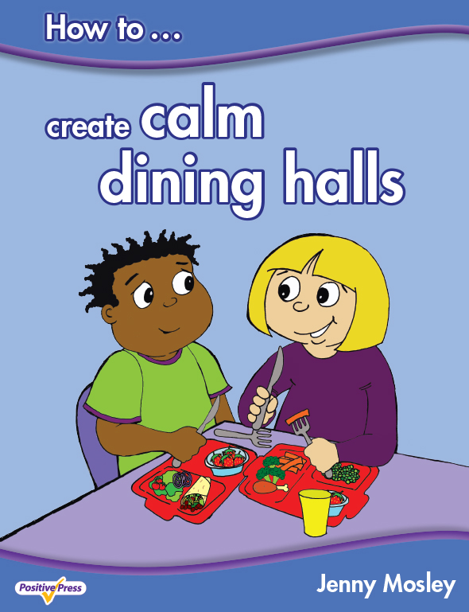
“Every part of the model has a positive impact on the school community and the successes achieved”
Fizz Starkey, ex Headteacher, NLE, SIP and Education Consultant

VIBRANT CIRCLE TIME FOR EARLY YEARS
Wednesday 10th May 2017
POWERFULLY POSITIVE LUNCHTIMES AND PLAYTIMES AND CALM DINING HALLS
MORNING WORKSHOP - Thursday 11th May 2017
Martin Frobisher Infant School, Church Road, Altofts, Normanton, WF6 2NU

Conference Trainer – Jenny Mosley
Jenny Mosley is a national and international trainer and acclaimed founder of the Quality Circle-Time model. Jenny’s work and motivation has had an impact in thousands of schools. She wrote, for the DfE, the circle-time guidance for Early Years, Primary and Secondary SEAL. She also wrote the Happier Lunchtimes and Playtimes Guidance for the Primary National Strategy. She has published the first ever book on ‘How to Create Calm Dining Halls’. Find out how Jenny’s ideas support British Values and the latest guidance from Ofsted.

Vibrant Circle Time for Early Years – how to build young children’s emotional resilience, confidence and learning power Wednesday 10th May 2017 - 9am – 3pm
During the day jenny will work with a class of very young children to demonstrate the huge potential of circle time to support children, to develop social and emotional skills and values even in a very short time. Jenny will use puppets, games and speaking and listening activities and show how her Five Skills and Five Step model of circle-time is simple and straightforward – and can be used, with safe ground rules, by any enthusiastic early years’ practitioner
Powerfully Positive Lunchtimes and Playtimes and Calm Dining Halls – Morning workshop
Thursday 11th May 2017 - 9am – 11.30am
Because Jenny is the leading pioneer of positive playtimes and the originator of zoning, playground friends and friendship stops – she will give many ideas to re-energise you playtimes. Jenny will highlight the importance of positive relationships and how these can motivate children to play well together and to relate well to mid-day supervisors and TAs. Delegates testify to the huge impact Jenny’s ideas have to revolutionise the dining hall systems and the ethos of the playground.
What past delegates say: “I just wanted to send an email saying how fantastic my staff found your course yesterday. All of them said how motivated they felt and they left buzzing rather than worn out which happens during other courses they have attended.” Amanda Parker, Nursery Manager, Here We Grow (The College Merthyr Tydfil)
“Please thank Jenny…she is truly inspirational. Playtimes are now much improved, and we are working on all the issues, having fun and playing lots……” Louise Siriwetchaphan, Pupil Support Worker, Beechwood Primary School, Leeds
Who are these courses for: Teachers, TAs, Nursery Nurses, Childminders, Lunchtime Supervisors, all Early Years practitioners, Headteachers. Everyone!
Cost: £115 per day. Group bookings (4 and over) £95 per head per day (all plus VAT). Lunch and refreshments included.
Lunchtimes workshop: £65 per delegate plus VAT
Venue: MARTIN FROBISHER INFANT SCHOOL, CHURCH ROAD, ALTOFTS, NORMANTON, WF6 2NU
To book a place: Please complete attached application form and fax back to 01225 755631 or email to joannap@jennymosley.co.uk. or post to Jenny Mosley Consultancies, 28A Gloucester Road, Trowbridge, Wilts BA14 0AA. www.circle-time.co.uk. If you have any queries please contact Joanna on 01225 767157.

