

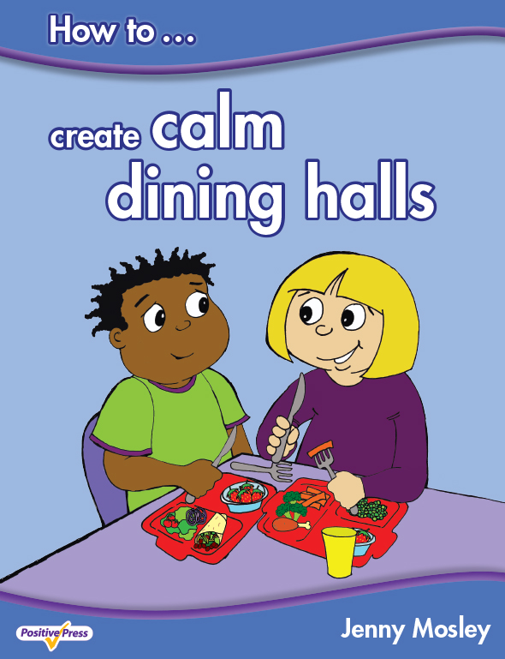

PROMOTING BETTER BEHAVIOUR FOR LEARNING
AND RESPECTFUL RELATIONSHIPS
Monday 16th October 2017
POWERFULLY POSITIVE LUNCHTIMES AND PLAYTIMES AND CALM DINING HALLS
Tuesday 17th October 2017
Terrace Road Primary School, Mount Pleasant, Swansea, SA1 6JD

Conference Trainer – Jenny Mosley
Jenny Mosley is a national and international trainer and acclaimed founder of the Golden model. Jenny’s work and motivation has had an impact in thousands of schools. She wrote, for the DfE, the circle-time guidance for Early Years, Primary and Secondary SEAL. She also wrote the Happier Lunchtimes and Playtimes Guidance for the Primary National Strategy. She has published the first ever book on ‘How to Create Calm Dining Halls’. Find out how Jenny’s ideas support British Values and the latest guidance from Ofsted.

Promoting Better Behaviour for Learning and Respectful Relationships
Monday 16th October 2017 from 9am – 3.00pm
This day looks at how teachers can promote Positive Learning Communities in the classroom by encouraging children to take responsibility for their own behaviour and relationships. An intensely practical day – Jenny will highlight the qualities teachers and children need to develop in order to promote PSHE, SMSC and emotional wellbeing. Jenny is passionate about working with the innate wisdom of children as a powerful forum for change so she will demonstrate a circle-time with a KS1 and a KS2 class with delegates observing and discussing on the impact it can have.
Powerfully Positive Lunchtimes and Playtimes and Calm Dining Halls
Tuesday 17th October 2017 from 9am – 3.00pm
This day will help your school create calmer dining halls and playgrounds. Jenny has hundreds of tried and tested ideas which can be immediately put into practice on your return. Unmissable for schools who have problems from lunchtimes which spill over into the afternoon affecting children’s learning and staff morale! For a school to get the best vale from the day Jenny encourages senior managers to attend so a true whole school dining hall and lunchtimes policy can be put in place.
What past delegates say: “I have had wonderful feedback from not only my staff but other heads too who sent their staff on the training. We have also found a way to get circle-time across the school weekly in each class……..our middays too have embraced your ideas to change playtimes. All commented on your enthusiasm and inspiration. How wonderful is all of that! Jennifer Richards, Headteacher, St Mark’s CE Primary, Bromley, Kent
Who are these courses for: Teachers, TAs, Lunchtime Supervisors, Headteachers. Everyone!
For a school to get the best value for the day Jenny also encourages senior managers to attend so a true whole school positive relationships framework can be put in place.
Cost: £125 per day. Group bookings (4 and over) £95 per head per day (all plus VAT). Lunch and refreshments included.
Venue: Terrace Road Primary School, Mount Pleasant, Swansea, SA1 6JD
To book a place: Please complete attached application form and fax back to 01225 755631 or email to joannap@jennymosley.co.uk. or post to Jenny Mosley Consultancies, 28A Gloucester Road, Trowbridge, Wilts BA14 0AA. www.circle-time.co.uk. If you have any queries please contact Joanna on 01225 767157.

