
Sharing the Learning Programme
“Education at the Heart of Regeneration”
Introduction
There is a long established pattern which acknowledges poverty as presenting barriers to children’s education, which means that they enter post primary school with lower than average attainment and dealing with social and economic problems that inhibit their learning. A proven route out of poverty is quality education and, in the light of the most recent report into child poverty which highlighted west Belfast as having the highest levels of child poverty, the West Belfast Partnership Board (WBPB) strategic and operational plan identifies education as a top priority area to be addressed if we are to improve the life chances of children, young people and their families and develop sustainable social and economic neighbourhood regeneration and renewal.
Historically the West Belfast Partnership has had a keen interest and focus on education. In 1998 the partnership set up the now famous Easter School, held annually in St Mary’s University College and the Aisling Bursaries, which are distributed to students living in the West Belfast electoral constituency who are about to embark or who are in Further and Higher Education or Training.

Addressing Achievement in a Connected Way
- Transition points: Surestart, Nursery, Primary, Post Primary, FE / RTO – development of information proforma / guide
- Strategic Planning: revised Strategic Education Steering Committee, development of a strategic education plan for WBPB, more robust communication and PR strategy
- Quality Assurance: Development of evidence based self-evaluation process
West Belfast Partnership Board Strategic Education Steering Committee: Identified Strategic Education Priorities 2015-2019
- Structural development to influence educational change
- West Belfast wide Strategic Education Plan – DE priorities and those of local Education community
- Communications

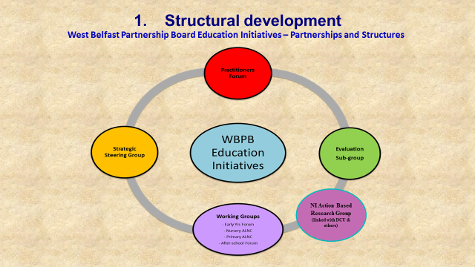

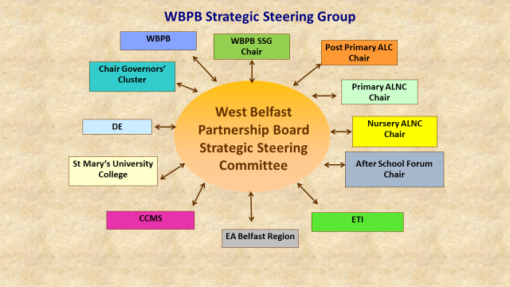

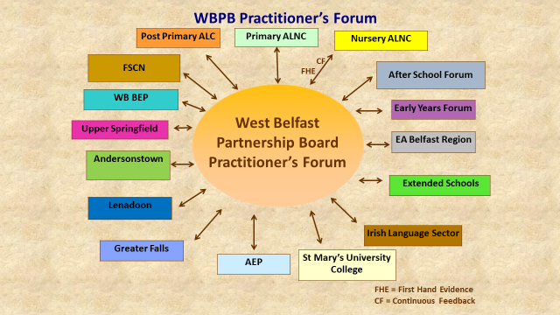

ETI Area Based Inspection and the West Belfast Partnership Education Strategic Steering Group
The West Belfast Partnership Board’s Education and Training Forum (ETF), formed in late 2010, was tasked with focusing on particular recommendations arising out of an Education and Training Inspectorate (ETI), Area Based Evaluation Report. The ETI report focused on the quality of strategic planning, learning and transition arrangements for education and training in west Belfast and the WBPB Education and Training Forum’s ToR followed that theme. The work of that Forum culminated in the production of an Outcomes Report which has been widely disseminated.
Our current work builds on that foundation and work has been undertaken which not only reflects the findings of the ETF but also to respond to government policies. The WBPB Education and Training Forum has been rejuvenated and is now a west Belfast area wide Education Strategic Steering Committee.

Partnership Impact
The tables below demonstrate that the GCSE results for pupils leaving West Belfast Schools showed a significant improvement from previous years. Post-Primary School Principals have said that partnership approach and the WBPB Education programmes and resources for GCSE Support in addition to the Easter School have had a real impact for young people. The WBPB Education programme of work has contributed to this improvement, alongside area based self-evaluation which was conducted under the advice of the Education and Training Inspectorate representative on the WBPB Education Strategic Steering Group and the input of other programmes including the Developing Social Change Signature Project. What is evident is that working together is definitely having a positive impact in terms of attainment levels.

The tables below presents the collation of internal school figures relating to GCSE examination results for those schools represented on West Belfast Area Learning Community, and is not subject to the rigour of SAER.
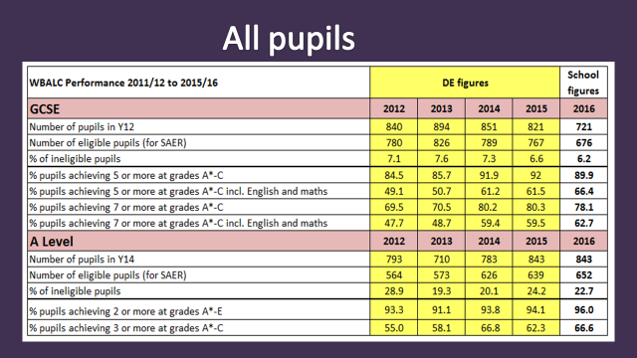
GCSE Results | 2015 – 2016 % increase | 2011 – 2016 % increase
5 or more Grades A* - C including Maths & English | 4.9% | 17.4%
7 or more Grades A* - C including Maths & English | 2.2% | 15%
A Level Results | 2015 – 2016 % increase | 2011 – 2016 % increase
2 or more Grades A* - E | 1.9% | 6.1%
3 or more Grades A* - C | 4.3% | 15.5%

GCSE attainment of pupils eligible for Free School Meals

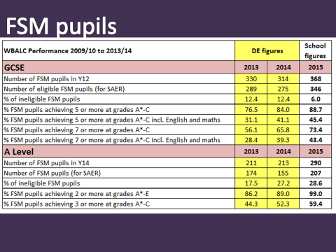

The table shows:
- 12.2% increase of students eligible for Free School Meals achieving 5 or more GCSEs at grades A* - C in 2015 than in 2013.
- 14.3% increase of students eligible for Free School Meals achieving 5 or more GCSEs at grades A* - C including Maths and English in 2015 than in 2013.
- 17.3% increase of students eligible for Free School Meals achieving 7 or more GCSEs at grades A* - C in 2015 than in 2013.
- 15% increase of students eligible for Free School Meals achieving 7 or more GCSEs including Maths and English at grades A* - C in 2015 than in 2013.

Post Primary West Belfast Area Learning Community (WBALC)

- WBALC has voluntarily gone beyond DE brief of collaboration on teaching of subjects across post primary schools.
- Underpinned by the principle of an area based organisation seeking effective self-evaluation allied to the highest possible standards across an area (area-based planning).
- Effective partnership with WBPB and Primary and Nursery ALNCs resulting in:
- Developing area wide targets and strategies
- Transition programmes addressing Literacy & Numeracy
- Easter school in Maths & English
- Introduction of Saturday Schools
- Key Stage 3 support, targeting Literacy & Numeracy
- Focus on self-evaluation across the area in schools and community– TCN, Focus/Common Log Book

Primary Area Learning Networking Community (ALNC)

- Working in partnership with Post Primary ALNC, Nursery ALNC and WBPB – focus on transition to improve standards in Literacy and Numeracy.
- Importance of communication across the phases e.g. Chair of Primary ALNC on WBPB Education Strategic Steering Group & PP ALC, Vice Chair on Practitioners Group.

3 clear objectives
- Dissemination of good practice
    - Quality Learning Experiences
    - Cluster Formation: SENCO, Pastoral Care/Safeguarding, Numeracy
    - Effective classroom strategies and approaches
    - Effective interventions – focus on underachievement
    - All schools and community gain and learn from expertise of each other - (Practitioners’ Forum)
- Self-evaluation
    - Ensuring what we do is effective, measurable and evidence based
    - Consistency in approach to self-evaluation – log book, impact and identifying trends and gaps
- Networking
    - Building trusting relationships with all cross phase
    - Creating effective links with all to ensure unnecessary repetition and effective workable curriculum which meets the needs of every individual child
    - All school staff buying in to process

Nursery Area Learning Networking Community (ALNC)
- Strengthened communication and relationships
- Development of pre-provider – Nursery information proforma
- Development of west wide resources
- Programmes in response to parental need
- Chair attends Primary ALNC meetings to ensure robust communications and joint planning and vice versa
Focus 2016 - 2018
- Nursery – Primary Transition Resource
- Further Development of Self-Evaluation Log Books
- Assessment, baseline and tracking systems.

WBPB Easter School
The Easter School provides tailored support for young people undertaking GCSE Mathematics examinations in the summer term. This additional tuition is aimed at those students who are considered to be borderline Grade C candidates, as identified by their schools.
The Easter school is a partnership between:
- WBPB who organise and manage the programme,
- Full Service Community Network / CCMS
- the schools who identify students, provide detailed information on which areas of the syllabus individual students are finding difficult, and
- St Mary’s University College who provide the accommodation and support; one which we at the Partnership consider supports the raising of the young people’s aspirations.
The environment and ethos of Easter School is one of relaxed but focused learning. Student feedback reinforces our opinion that this change of learning environment and additional support often provides the encouragement students require to keep on studying at a time when their predicted grades may encourage the reverse. Over 3,000 students have participated in the popular programme since its introduction in 1998 and each year the Easter School continues to grow. Each subject is taught through both English and Irish medium by qualified and highly experienced teachers. The environment and ethos of Easter School is one of relaxed but focused learning, aiming to boost the grade and pass rate of attending students.

2016 WBPB Easter School
In 2016 262 students attended from 11 Post Primary schools in West Belfast, including 17 students from Shankill and Donegal Rd
Gender Subject Breakdown
Males: 123 171 students: Maths revision
Females: 139 91 students: English revision
Total: 262 44 students: Maths and English

Examination Results Analysis

Subject Maths | Percentage
Easter School Participants Achieving grades A*-C in GCSE Mathematics  Achieving higher than predicted grade  Maintaining Grade C | 94%  59.4%  34.6%

Subject English | Percentage
Easter School Participants Achieving grades A-C in GCSE English  Achieving higher than predicted grade  Maintaining Grade C | 96%  54%  42%

Maths: English:
94% achieved grade C or above 96% achieved grade C or above
59.4% achieved higher than predicted grade 54 % achieved higher than predicted grade
34.6% maintained Grade C 42% maintained Grade C

In the spring of 2013 the Partnership was approached by the Department of Education to support the establishment of Easter schools across the Belfast Area Partnerships. WBPB were able to secure some money for this guidance and this funding was also used to pilot a 6 week Saturday school, focusing on GCSE support for English and Maths, over 100 young people attended. This has been expanded with over 1200 students in 9 Post Primary schools and 4 community setting receiving additional supports to date.
Aisling Bursaries
The Aisling Bursaries are an education bursaries scheme delivered by the West Belfast Partnership Board. 2016 marked the 16th year of the Aisling Bursaries, which provide a valuable vehicle enabling students to access further and higher education and training. Businesses, community enterprises and individuals contribute to the Bursary Fund and make a firm commitment to developing the skills of the local community and enhancing young people’s capacity to achieve their full potential.
In 2017, 49 students from West Belfast and Shankill were awarded either £1,000 or £500 with a total of £31,500 donated through bursaries. Since the Aisling Bursaries began in 2000 £606,000 has been donated to a total of 720 students.

Transition Summer School
May 2013 the Partnership secured funding from the Department of Education (DE) to support transition from primary to post primary. Based on previous work through Integrated Services for Children and Young People and Alternative Education Provision it was decided to use this funding to develop a Transitions Summer School, which we has become a model of good practice across the city.
August 2013 – August 2017, 986 young people have taken part in the 5 day programme which focused on literacy, numeracy and personal development, introducing STEM subjects by way of visits to the Planetarium, W5 and Honeydew Java Programming. Teachers from both primary and post primary schools worked with the young people and the programme is delivered in both English and Irish to accommodate the large number of Irish speaking students. The programme is offered free of charge to all children in that age group in the west Belfast area and includes lunch and transport as required.
Department of Education Sharing the Learning Programme
This Programme of work takes into consideration the range of work in education being carried out by various sectors and initiatives in west Belfast and builds on and adds additional value to that work.
This programme does, therefore, act as a comprehensive programme of work in order to ascertain the impact of this model of work and determine whether it should be implemented in others areas of social deprivation. The core focus of this programme is to strengthen the involvement of parents, carers and the family unit in the education of children and young people by working in partnership with families, schools and the local community.
Partnerships

WBPB has continued to build, develop and strengthen structures and partnership approaches in west Belfast. As West Belfast Partnership Board continues to work with our schools and community organisations, we have witnessed our Primary and Nursery Area Learning Networking Communities (ALNC) going from strength to strength and have formed a West Belfast Early Years Forum with representatives from community day-care, SureStarts and Nursery schools. Our networks include 51 Post Primary, Primary and Nursery schools across West Belfast, 17 community based After School providers and numerous community organisations and statutory partners.

Through robust and innovative structures we have developed a number of resources with our local schools and the Education Authority, including Transition proforma for each stage in a child’s education journey, Literacy and Numeracy Transition Bridging Units for use with Primary 7 and Year 8 students, additional books for the Harper the Wonder Dog series to promote reading at home and input in to the resource written by the Education Authority Early Years Inclusion Team and schools to support transition from Nursery to Primary for children with Special Educational Needs
Dissemination of Best/Next Practice
There is a very successful and beneficial networking and community development partnership process with schools and community in West Belfast and WBPB has been funded by the Department of Education to assist other areas of Belfast to begin to develop this process and the associated structures. This will promote, develop and strengthen internal relationships within schools with teachers / management / Boards of Governors and external relationships between schools and schools and community, which will facilitate professional development, trust building, sharing best practice and structural development. This will in turn have a positive effect on schools and community and create a sense of joint ownership through community and school “buy in” and lead to a shared vision for education.
WBPB are working to:
- Assist other areas in Belfast and regionally to build the capacity of schools and community to work together and support each other in order to raise attainment levels across the education spectrum
- Promote an ethos of non-isolation and interdependency by assisting areas to break down barriers and boundaries internally in school settings and between schools and community.
- Support other areas of Belfast and regionally to begin to develop the process and the associated structures which currently exist in west Belfast and which ensure a very successful and beneficial networking and community development partnership in and between schools and community
- Promote, develop and strengthen internal relationships within schools with teachers / management / Boards of Governors and external relationships between schools and schools and community, which will facilitate professional development, trust building, sharing best practice and structural development. This will in turn have a positive effect on schools and community and create a sense of joint ownership.

WBPB disseminates next practice to maximum effect by:
- Disseminating for Awareness in west Belfast, other areas of Belfast initially and regionally in the longer term
- Disseminating for Understanding to those groups and organisations, for example Area Learning Communities and Neighbourhood Partnerships, who can benefit from what WBPB to offer in terms of establishing structures and collaborative working models.
- Disseminating for Action to those groups and organisations who need to have in depth knowledge and understanding of the Education work of WBPB in order to adopt approaches to influence and bring about change and more collaborative working to raise education attainment

Services
Whilst disseminating best practice and sharing learning, WBPB has continued to develop and implement a range of services and activities which are designed to facilitate the creation of a seamless education pathway for children and young people. The services are designed to continue to raise attainment levels across the education spectrum for children and young people in west Belfast experiencing disadvantage through poverty, exclusion and social emotional behavioural difficulties.
The WBPB Sharing the Learning Programme has introduced a range of programmes and activities which create a wraparound service that is designed to address what we believe to be a root cause of educational underachievement as recognised by the EA Belfast Region, Education and Training Inspectorate (ETI), local Schools and Community Groups and by the Department of Education.
The overall aim of this Project is to facilitate the creation of a seamless education pathway for children and young people. The services are designed to help break the cycle of disadvantage by delivering targeted interventions at a number of key levels of educational attainment including:
- Early Years
- Pre-school
- Nursery school
- Primary school
- Post Primary level
- GCSE support,
- Transition support

There is also a focus on curriculum support for parents and carers, recognising them as the primary educators of their children, so that they might, in the long-term, be able to offer these supports to their children and raise participation and enjoyment of learning.
The core focus of the Project is aimed at raising the attainment levels across the education spectrum for children and young people experiencing disadvantage and exclusion through poverty exclusion and SEBD (Social Emotional Behavioural Difficulties).
The innovation of this proposal lies in the fact that it is a wraparound support approach that is inclusive of parents and families, building on the existing work that being carried out in the local area.
Support for families with preschool children
Successful transition experiences for young children have been widely identified and researched as a key factor of engaging and motivating young children to learn. We offer a range of programmes aimed at families with young children in west Belfast in order to support them in ensuring that their children are school ready for nursery. The services and programmes include:
- Programmes which engage young single mothers living in hostel accommodation in the west Belfast area;
- Support for these parents to create school routines for their children;
- Literacy support for parents;
- Numeracy support for parents;
- Closer collaboration between nurseries or pre-schools and home including the opportunity for parents and staff to share information prior to child starting pre-school.
Nursery to Primary
The important transition period from nursery to primary level is supported by:
- Promotion of positive parental attitudes and engagement;
- Promotion of the importance of family learning;
- Promotion of the home learning environment;
- Assistance in parental understanding of the school curriculum;
- Encouragement of family activities such as storytelling and reading;
- Support for development of school routines within the home.

Primary Support
Support for Primary school aged children is a major element of the proposed programme. This involves:
- Support for literacy, numeracy and ICT within the school day;
- Provision of homework and study support for children identified by parents, schools and local community organisations as in need of additional assistance;
- Use of technology as a tool to improve literacy and numeracy, involving the use of IPads in order to increase awareness of new and emerging technology.

Primary Support during Summer Break
This particular programme of work involved the establishment of Summer Schools in the local area with focus on:
- Identification of children in Year 5-7 who are in need of additional support;
- Creation of learning hubs in the local community;
- School involvement in learning hub creation;
- Improving literacy;
- Improving numeracy;
- Morning learning sessions;
- Afternoon recreation sessions;
- Participation of parents / carers.
The Summer Schools take place during the summer months in order to ensure that the gap between summer and autumn school terms is not detrimental to the learning of the child.
Transition Support
The importance of successful transition between the education sectors is vital and many children and young people who fail to achieve a positive transition between education sectors do not reach their potential. Transition support offers the opportunity for young people to succeed in education.
The importance of successful transition between home and nursery to primary and post-primary school is clear. If children do not achieve a positive transition between schools and stages, they often do not reach their potential in later public examinations. The ETI Inspectorate Report on west Belfast (2010) identified transitions as a key area which needed attention in west Belfast.
This programme supports transition at all stages and will work with parents and carers to raise educational aspiration of their children and as a result raise attainment in the greater West Belfast area.
The need to ensure successful transition here is also underlined by international evidence. The results of PIRLS and TIMSS show that our primary school pupils are performing well above the international average in both literacy and in mathematics. This is supported by our Key Stage 2 outcomes, which show high attainment at primary level education. Critically, there is clearly a decline in the proportion of pupils achieving at the expected level in both communication and using mathematics by the end of Key Stage
Performance measured by PISA at 15 is around the OECD average in reading and maths with a stark contrast between the performance of our most and least deprived children.
A transition programme is currently being delivered in a number of primary schools in west Belfast and our plan is to extend this to all west Belfast primary schools and to develop a programme that deals with transition from nursery to primary so that education in the area is a seamless process.
More recently, West Belfast Partnership Board has worked in partnership with the WB Post Primary Area Learning Community, Primary ALNC, EA Belfast Region and local schools to develop bridging units for Literacy and Numeracy Year 7 – Year 8 Transition.
Post Primary Support – Years 8 - 10
The Post Primary programme supports children in years 8-10, who are identified as struggling and in need of additional supports through a range of services that will include:
- Supporting pupils to further develop their literacy and numeracy skills delivered both on 1-1 and small group basis by a team of literacy and numeracy support staff;
- Encourage pupils to attend school regularly;
- Support strong links between schools and community;
- Develop life skills programmes that involve the full family unit;
- Development of school routines;
- Development of study routines;
- Additional study support for identified students;
- Induction programme in all post primary schools for young people and parents / carers;
- Support for STEM subjects;
- Support for parents / carers to ensure effective engagement and retention of children in school.
GCSE Support
The core objective of West Belfast Partnership and our education partners is to raise educational attainment levels and provide support to those children from disadvantaged backgrounds who are at risk of not achieving their full potential due to socio-economic background and lack of accessible support services. GCSE specific support is provided by:
- Expansion of WBPB Easter School in order to offer support in both Maths and English to young people as identified by parents and school as being at risk of not attaining Grade C or above at GCSE level.
- Saturday School provision to offer GSCE support in both Maths and English.
- Both programmes listed above take place in St Mary’s University College and focus on children in receipt of FSMs.
- Support for young people to achieve at least 5 GCSEs at A*-C (or equivalent) including GCSEs in English and maths

A bespoke monitoring and evaluation framework has been developed, in conjunction with the Project Team and MER (Monitoring, Evaluation and Review) Sub Group, by WBPB MER officer, who has extensive experience of MER, both in the education and health sectors. Monitoring, evaluation and review is on-going during the life of the programme. Each programme is assessed from the beginning in order that improvements and relevant adjustments may be made when necessary
A bespoke programme of learning based on identified need is delivered, taking into consideration the areas of improvement recommended by the ETI area inspection team.
EU Research Project
Following a site visit in 2012 by an international delegation led by Dr Martin Brown from Dublin City University, WBPB, WB Post Primary ALC and Primary ALNC are also taking part in an OECD evaluated EU Research project focusing on the factors which make polycentric inspections successful and the follow up partnership work involved.
West Belfast was chosen as the case study for this research because it has a vibrant, flourishing education network which includes nursery, primary and post primary schools as well as community organisations.
In November 2015 the launch of the Erasmus+ Interim Case Study Report: “School Inspections in a Polycentric Context” took place in the Long Gallery, Stormont.
The report by the Centre for Evaluation, Quality and Inspection at Dublin City University details a case study of school and stakeholder networking and area based inspection in N Ireland and notes that increased cooperation, partnership working and sharing, closely linked to area based or polycentric inspection, can contribute significantly to enhanced educational outcomes for students.
Following the successful Erasmus+ research launch in November 2015 which strongly endorsed the work of West Belfast Partnership Board and our local schools, a delegation of Bulgarian teachers, principals, senior inspectors and academics from Sofia University, together with our partners from Dublin City University, visited West Belfast in order to seek out elements of best practice on school evaluation and school community, area based evaluation. The delegation visited West Belfast Partnership Board, St Oliver Plunkett Primary School and Corpus Christi College, followed by an informal meeting with the Stormont Education Committee.
The delegation specifically requested to visit West Belfast given the ground breaking work on evaluation that has been spear headed by Dr. Patrick Shevlin, West Belfast Partnership Board and the West Belfast Post Primary School Area Learning Community, which has 10 schools as members.
“I am not surprised that there is such an increasingly growing interest in West Belfast education in Europe and elsewhere. This is an impact model of schools and community partnership that should be not only be used in Northern Ireland but in other areas of Europe and elsewhere.” Dr. Martin Brown, Centre for Evaluation, Quality and Inspection at Dublin City University Institute of Education
Statistics: Education and Training Outcomes in West Belfast: NISRA 2010
Belfast West has a slightly younger age profile than that of Northern Ireland with 24.1% of the population aged 16 and under (vs 21.5% of the average population of NI aged 16 and under). There are currently 19,907 pupils that reside in West Belfast that attend a funded school (this figure includes Shankill Ward). This represents 43.5% of all pupils in Belfast City Council area.
Approximately 49% of West Belfast pupils are entitled to free school meals (compared to 40.3% overall in Belfast LGD, and 25.7% for Northern Ireland overall). Free school meal entitlement in West Belfast has increased by eight percentage points compared to five years ago; however, the Belfast figures have also experienced a similar rate of growth in the same time period. As one Primary School Principal noted recently “whilst children on Free School Meals registers is around the 50% mark in the whole of West Belfast; in some schools, including my own, the Free School Meal band of children from the local community is at more than 80%. It is only when I add the children from overseas or other communities to my register that the free school meal band is reduced to 72%”.

West Belfast Demographic Community Profile data relevant to educational attainment show:
- 25.1% of school leavers entered Higher Education in 2007 - 2008, in comparison with the NI average of 38.5%.
- 22.4% are recorded as entering training in the same year (2007 – 2008), compared with an NI average of 15.9%.
- The percentage for school leavers achieving two or more A levels is 33.3% as opposed to 44.6% of schools leavers in NI overall. West Belfast is the Constituency with the 2nd
- Lowest proportion of pupils achieving at least two A Levels.
- The percentage of School leavers achieving 5 GCSE (grade A*- C including English and Maths) is 37.7%, whereas the NI average is 62%.
- A lower proportion of Belfast West school leavers achieve at least five GCSEs at grades A*-C compared to all NI.
- The Belfast West percentage of key stage 2 learners achieving Level 4 or above in 26.8% for English and 35.2% for Maths. The respective NI averages are 27.7% (English) and 41.1% (Maths).
- The proportion of post primary pupils with a Special Education Need (SEN) at stages 1 to 4 was much higher for Belfast West than the NI proportion, which stands at 14.9%.
- 27% of pupils in West Belfast require additional support with their learning, almost twice as high as the NI average 15.5%.
- 36.1% of pupils in West Belfast constituency are at SEN stages 1-5, compared to 30.4% in Belfast.

Attainment levels of pupils living in West Belfast are lower than pupils living in Belfast LGD in key stages 1, 2 and 3. The biggest difference is at key stage 2, where the difference in the proportion that achieve at least a level 4 is six percentage points lower in Communication in English and four in Using Maths for West Belfast pupils. In fact, pupils resident in West Belfast perform poorest of all constituencies in key stage 2 Communication in English and Using Maths.

A much lower proportion of people in West Belfast leave school with qualifications and have achieved degree level qualifications compared to Belfast as a whole. However, statistics show that there has been an improvement in qualifications achieved by the population aged 16 to 74 years during the past decade:
- In 2011 38.1% of the population aged 16 to 74 years had no qualification: compared to 51.5% in 2001; and 38.1% Belfast LGD in 2011.
- In 2011 15% of population aged 16 to 74 years had degree level/level 4 or higher qualifications: compared to 8.3% in 2001; and 28% Belfast LGD in 2011.
These data evidence a substantial change in educational attainment among West Belfast residents in a relatively short space of time. Data is presented later in the Status Report presenting increased GCSE levels of attainment in both 2014 and 2015 by students in West Belfast.

Pupils resident in West Belfast (including the Shankill) have a lower attendance rate than all other constituencies for each of primary, post-primary and special schools in 2012/13. As such, overall attendance rate in of West Belfast pupils is slightly lower than the overall Belfast LGD rate (92.3% and 92.8% respectively). Despite the poor attendance, there has been an improvement over the last five years, increasing from 91.7% in 2008/09 to 92.3% in 2012/13. This has increased in line with attendance of all pupils resident in Belfast LGD.

Department of Education – Statistics and Research Team, Characteristics of Pupils Resident in West Belfast , September 2014
Department of Education – Statistics and Research Team, Characteristics of Pupils Resident in West Belfast , September 2014 West Belfast Partnership Board have asserted their rights of this work under the Copyright, Designs and Patent Act, 1988. No part of this briefing paper may be changed or added to without the permission of the publisher (WBPB). All rights reserved

