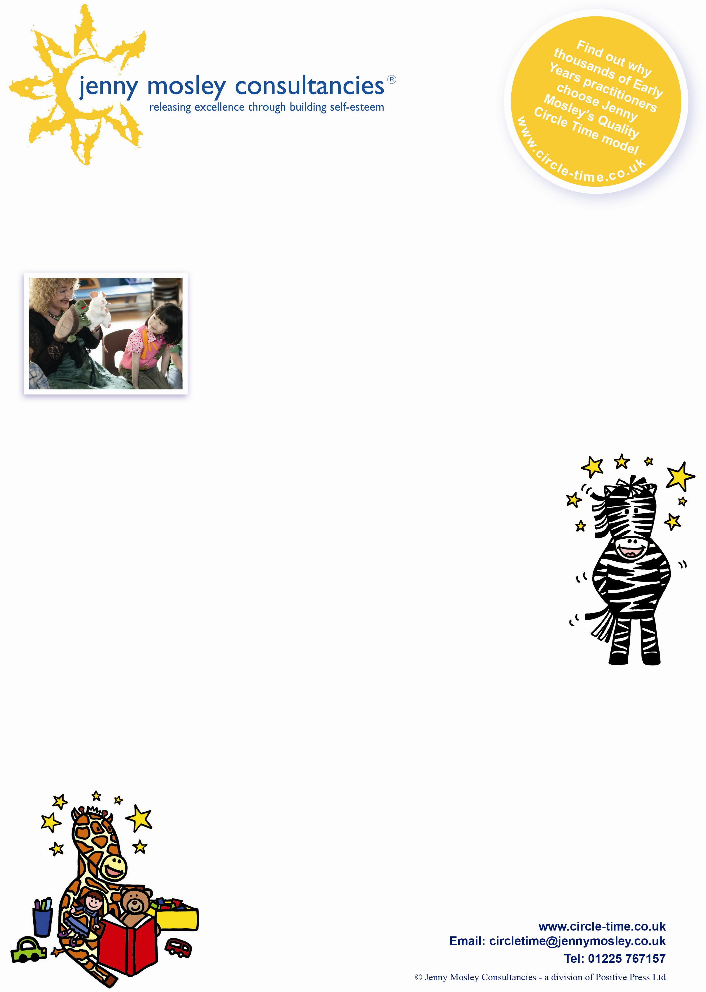



**What past delegates say**

***"Jenny's live demonstration was an absolute "masterclass" of how to engage very young children, fresh into the Year R class, through circle time. She had every single one of the 30 Year R children completely entranced by her energy, enthusiasm and warmth; skilfully using puppets, actions, modelling, highly effective questioning promoting active participation at their level for a staggering 45 minutes. This is undoubtedly THE way to deliver the Golden Rules to Early Years children! Staff watched, mesmerised and enthralled and left the room eager to implement the strategies to children in their classes. We feel most privileged to have observed Jenny deliver a truly outstanding session that had such a marked impact on not only the teachers but also the children in our school. Many thanks!"***

***Jane West,******Deputy Headteacher, Orchard Infant School, Dibden Purlieu***

Jane West, **Deputy Headteacher, Orchard Infant School, Dibden Purlieu**

**Cost**: £65 plus VAT per person

**Venue: Moorlands School Federation, Chantry Mead Road, Bath, BA2 2DE**

**Who’s it for:** Teachers**,** Nursery Nurses, Childminders, all Early Years practitioners!

**To book a place:** please complete attached application form and fax back to 01225 755631, email to [joannap@jennymosley.co.uk](mailto:joannap@jennymosley.co.uk) or post to Jenny Mosley Consultancies, 28A Gloucester Road, Trowbridge, Wilts, BA14 0AA. If you have any queries please contact Joanna on the number below.

**What makes this training workshop special?**

During the day Jenny will work with a class of very young children to demonstrate the huge potential of circle time to support children to develop social and emotional skills and values even in a very short time. Jenny will use puppets, games and speaking and listening activities and show how her Five Skills and Five Step model of Circle-Time is simple and straightforward – and can be used, with safe ground rules, by any enthusiastic early years’ practitioner.

Jenny Mosley is the highly acclaimed author and founder of the Quality Circle Time model. She wrote the circle time guidance for the government’s Early Years Social and Emotional Aspects of Development (S.E.A.D). Her seminal book ‘Here We Go Round; Quality Circle Time for 3 to 5 year olds’ continues to be a best seller and Jenny is now working with the government sponsored NDNA (National Day Nursery Association) to promote values, for children and the adults around them, through a set of Golden Rules board books for babies and toddlers.

***The Early Years Pupil Premium (EYPP) is a major development for funding…to support disadvantaged 3 and 4 year olds….in the DES report ‘Intervening Early’ evaluators reported that JENNY’s programme “can be used to enhance personal and social development and to develop a sense of self worth….***

***particularly for those with socialisation problems”***

**Address**

**Vibrant Circle Time**

**For Early Years**

**Monday 3rd December 2018 from 9am – 11.30am**

**What delegates will gain from the workshop**

* Inspiration to find new ways to make their own circle times exciting and vibrant for young children
* Determination to develop a personal energy care plan for themselves
* Understanding of the spiritual dimension of their work and how to ‘Be The Change You Want To See’ (Gandhi)
* Knowledge of how recent research in emotional intelligence and neuroscience can illuminate their interactions with children
* Excitement about the power of fun and games to help children (and adults) learn!!