

**Conference Trainer – Jenny Mosley**

Jenny Mosley is a national and international consultant and is acclaimed for her energy and inspirational presentations. Jenny’s work and motivation has had an impact in thousands of schools. In the UK, Jenny wrote the ‘Happier Lunchtimes and Playtimes Guidance’ for the Primary National Strategy that went out to all schools. She has written over twenty books and resource packs on how to promote purposeful and creative play in the yard. Her seminal ideas were first presented in the mid 90’s on a BBC documentary ‘Just One Chance’ – and highlighted how children take responsibility and leadership roles in the yard. Jenny’s ‘Positive Playtimes’ is still a best-selling book used by thousands of schools.

**Course Description**

This workshop will inspire staff to want to go back to school and implement many of Jenny’s ideas. She is a pioneer of zoning yards – and helping all the delegates to focus on the wide range of activities that could be implemented simply and easily by the children to support positive play. She has ideas to help football be a more positive activity – as opposed to one that created problems in the afternoon. Jenny is a great believer that often in the yard, it is not bad behaviour – it is bored behaviour. We have a generation of children who are losing the ability to play due to our technological revolution and families being under time pressures. Typical comments after Jenny’s input include “our staff have embraced all your ideas to change playtimes. Everyone commented on your enthusiasm and inspiration and how impactful the strategies are… how wonderful is that” Jennifer Richards, Headteacher, St Marks CE Primary, Bromely, Kent.

## What past delegates say

*“My head is buzzing with new ideas and I can’t wait to spread some joy! I would love everyone at my workplace to feel exactly the same as me! I feel absolutely motivated and how I felt when I first started this job 15 years ago!”*

Mim Slater, TA, Northborough Primary School

*“Please thank Jenny…she is truly inspirational. Playtimes are now much improved, and we are working on all the issues, having fun and playing lots……”* Louise Siriwetchaphan, Pupil Support Worker, Beechwood Primary School, Leeds

**Who is this day for?** It is for lunchtime supervisors, teaching assistants and anyone who does lunchtime duties.

**For a school to get the best value for the day Jenny also encourages senior managers to attend so a true whole school positive relationships framework can be put in place.**

**Cost:** €80.00 per head.

**Venue: Saint Joseph’s National School, Macroom Road, Coolock, Dublin 17**

**To book a place:** Please complete attached application form and fax back to 0044 1225 755631 or email to [lucya@jennymosley.co.uk](mailto:lucya@jennymosley.co.uk) or post to Jenny Mosley Consultancies, 28A Gloucester Road, Trowbridge, Wiltshire, England, BA14 0AA. [www.circle-time.co.uk](http://www.circle-time.co.uk). If you have any queries please contact Lucy on 0044 1225 767157.

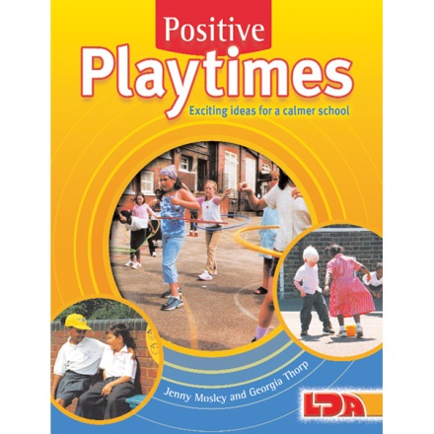

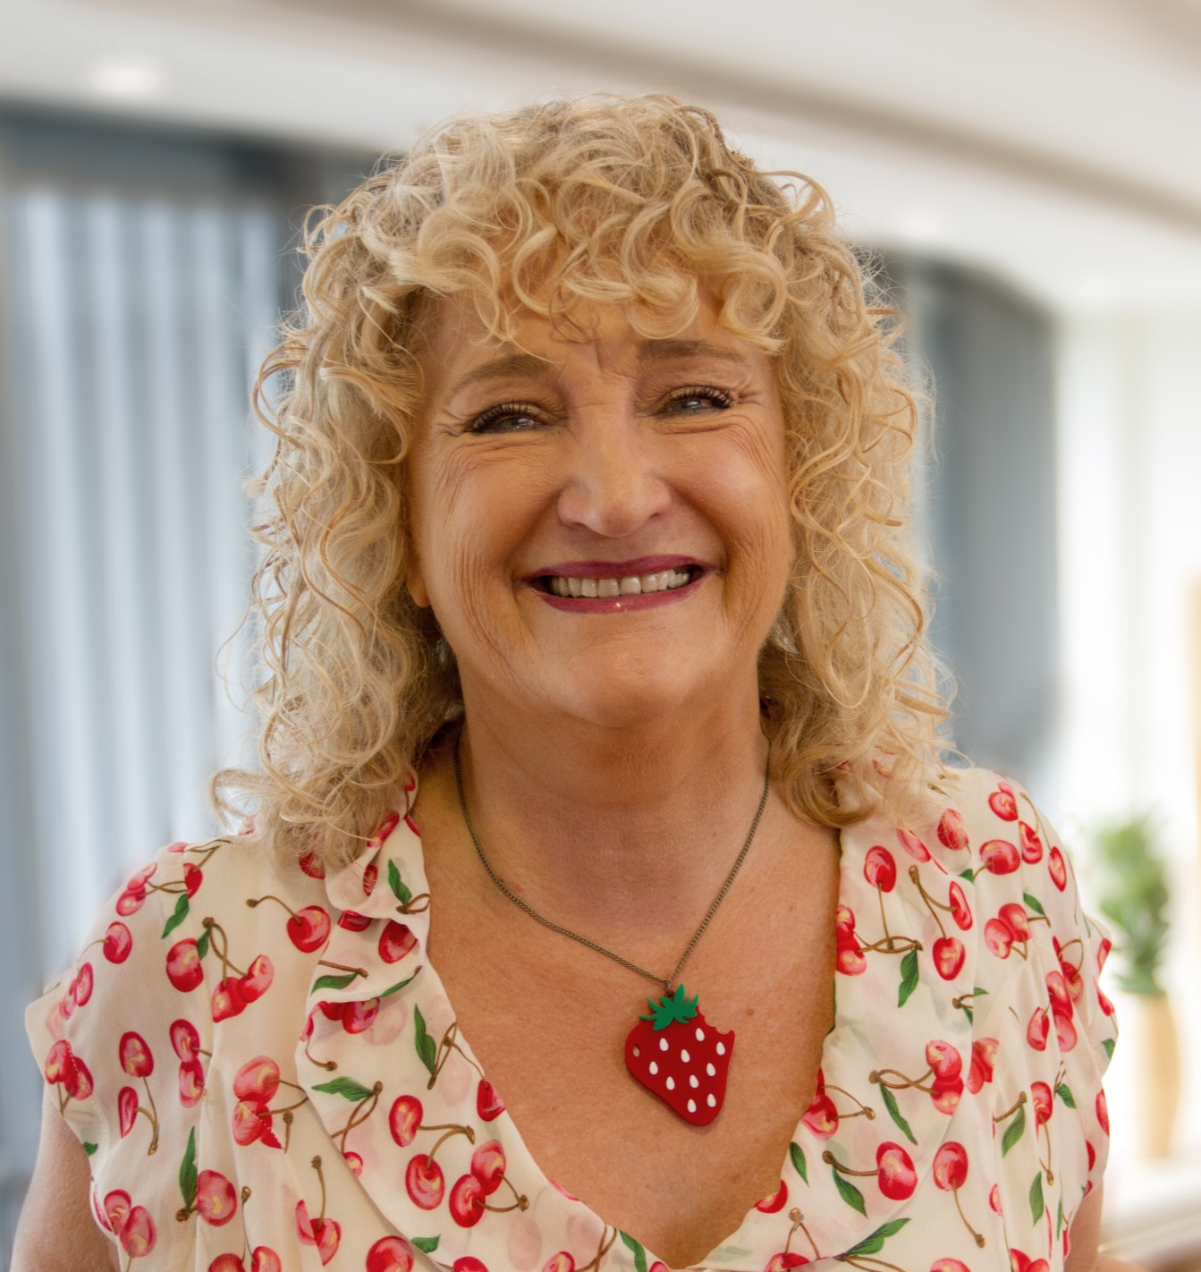

**HOW TO PROMOTE POWERFULLY POSITIVE BREAKTIMES**

**Saturday 30th March 2019 – 9.15am – 1.00pm**

**Saint Joseph’s National School, Macroom Road, Coolock, Dublin 17**