

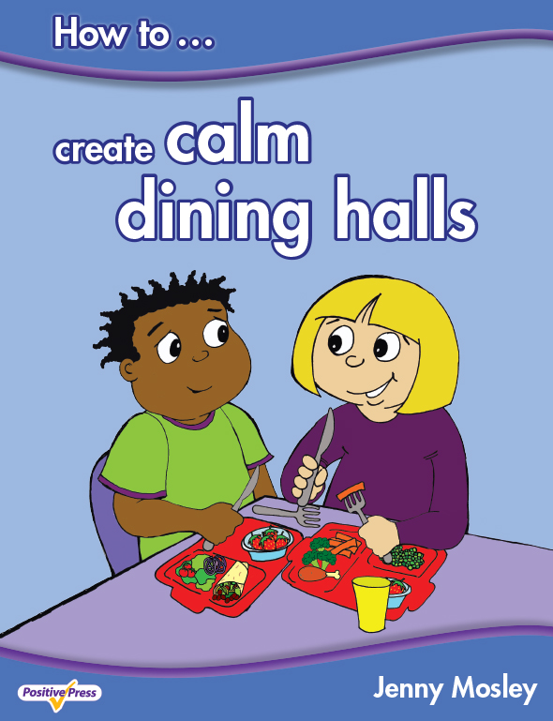

EMOTIONAL HEALTH AND WELLBEING FOR LEARNING
Thursday 16th May 2019 from 9am – 3pm
POWERFULLY POSITIVE LUNCHTIMES AND PLAYTIMES AND CALM DINING HALLS
Friday 17th May 2019 – MORNING WORKSHOP from 9am – 11.30am
Black Lane CP School, Long Lane, Pentre Broughton, Wrexham, LL11 6BT

Conference Trainer – Jenny Mosley
Jenny Mosley is a national and international trainer and acclaimed founder of the Golden Model. Jenny’s work and motivation has had an impact in thousands of schools, nationally and internationally. She wrote, for the U.K. DfE, the circle-time guidance for Early Years, Primary and Secondary SEAL. She also wrote the Happier Lunchtimes and Playtimes Guidance for the Primary National Strategy. She has published the first ever book on ‘How to Create Calm Dining Halls’. Jenny has lead a series of successful workshops and conferences across Wales for the last 15 years. Find out how Jenny’s ideas support the New Curriculum and Wellbeing.

Emotional Health and Wellbeing for Learning
Thursday 16th May 2019 from 9am – 3pm
This day looks at how teachers can promote Positive Learning Communities in the classroom by encouraging children to take responsibility for their own behaviour and relationships. An intensely practical day – Jenny will highlight the qualities teachers and children need to develop in order to promote PSE and emotional wellbeing. Jenny is passionate about working with the innate wisdom of children as a powerful forum for change so she will demonstrate a circle-time with a KS1 and a KS2 class with delegates observing and discussing on the impact it can have.
Powerfully Positive Lunchtimes and Playtimes and Calm Dining Halls – MORNING WORKSHOP
Friday 17th May 2019 from 9am – 11.30am
This day will help your school create calmer dining halls and playgrounds. Jenny has hundreds of tried and tested ideas which can be immediately put into practice on your return. Unmissable for schools who have problems from lunchtimes which spill over into the afternoon affecting children’s learning and staff morale! For a school to get the best value from the day Jenny encourages senior managers to attend so a true whole school dining hall and lunchtimes policy can be put in place.
What past delegates say: “The demonstration circle was brilliaint…….how wonderful to see 9 year old boys with their magical skipping ropes!! Both days reminded us all of the core values of education and the joy of working with children”. Wendy Ostler, Cydlynydd Ysgolion lach/Healthy Schools Coordinator, Conwy Borough Council.
Who are these courses for: Teachers, TAs, Lunchtime Supervisors, Headteachers. Everyone!
For a school to get the best value for the day Jenny also encourages senior managers to attend so a true whole school positive relationships framework can be put in place.
Cost: Thursday 16th May - £125 per day. Group bookings (4 and over) £95 per head per day (all plus VAT). Lunch and refreshments included. Friday 17th May - £65 per head plus VAT
Venue: Black Lane CP School, Long Lane, Pentre Broughton, Wrexham, LL11 6BT
To book a place: Please complete attached application form and fax back to 01225 755631 or email to joannap@jennymosley.co.uk. or post to Jenny Mosley Consultancies, 28A Gloucester Road, Trowbridge, Wilts BA14 0AA. www.circle-time.co.uk. If you have any queries please contact Joanna on 01225 767157.

