

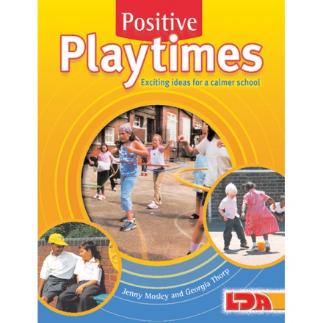

PROMOTING MENTAL HEALTH AND WELLBEING IN INCLUSIVE, CALMER CLASSROOMS
Friday 13th September 2019 (9.00am – 3.00pm)
HOW TO PROMOTE POWERFULLY POSITIVE BREAKTIMES
Saturday 14th September 2019 (9.15am – 12.30pm)
Scoil Mhuire, Racecourse Road, Clifden, Co Galway, Ireland 095-21353

Conference Trainer – Jenny Mosley
Jenny Mosley is a national and international consultant and is acclaimed for her energy and inspirational presentations. Jenny’s work and motivation has had an impact in thousands of schools. In the UK, Jenny wrote ‘Happier Lunchtimes and Playtimes Guidance’ for the Primary National Strategy that went out to all schools. She has written over twenty books and resource packs on how to promote purposeful and creative play in the yard. Her seminal ideas were first presented in the mid 90’s on BBC documentary ‘Just One Chance’ – highlighting how children take responsibility and leadership roles in the yard. Jenny’s ‘Positive Playtimes’ is still a best-selling book used by thousands of schools.
Promoting Mental Health and Wellbeing in Inclusive, Calmer Classrooms
Friday 13th September 2019 9.00am – 3.00pm
This day looks at how teachers can promote Positive Learning Communities in the classroom by encouraging children to take responsibility for their own behaviour and relationships. An intensely practical day – Jenny will highlight the qualities teachers and children need to develop in order to promote social and emotional wellbeing. Jenny is passionate about working with the innate wisdom of children as a powerful forum for change so she will demonstrate a circle-time with an Infant Class and a Third or Fourth class with delegates observing and discussing on the impact it can have.
How to Promote Powerfully Positive Breaktimes
Saturday 14th September 2019 9.15am – 12.30pm
This workshop will inspire staff to want to go back to school and implement many of Jenny’s ideas. She is a pioneer of zoning yards – and helping all delegates focus on the wide range of activities that could be implemented simply and easily by the children to support positive play. She has ideas to help football be a more positive activity – as opposed to one that created problems in the afternoon. Jenny is a great believer that often in the yard, it is not bad behaviour – it is bored behaviour. We have a generation of children who are losing the ability to play due to our technological revolution and families being under time pressures. Typical comments after Jenny’s input include “our staff have embraced all your ideas to change playtimes. Everyone commented on your enthusiasm and inspiration and how impactful the strategies are… how wonderful is that” Jennifer Richards, Headteacher, St Marks CE Primary, Bromley, Kent.
What past delegates say: “I have had wonderful feedback from not only my staff but other heads too who sent their staff on the training. We have also found a way to get circle-time across the school weekly in each class……..our middays too have embraced your ideas to change playtimes. All commented on your enthusiasm and inspiration. How wonderful is all of that! Jennifer Richards, Headteacher, St Mark’s CE Primary, Bromley, Kent
Who are these courses for: Teachers, SNA’s, Principals, Support Staff - Everyone!
For a school to get the best value for the day Jenny also encourages senior managers to attend so a true whole school positive relationships framework can be put in place.
Cost: Friday 13th September - €110 plus vat (total €132) per head. Group bookings of 4 and over €95 plus vat (total €114) per head per day. Lunch and refreshments included.
Saturday 14th September - €70 plus vat (total €84) per head. Refreshments included.
Venue: Scoil Mhuire, Racecourse Road, Clifden, Co Galway, Ireland 095-21353
To book a place: Please complete attached application form and fax back to 01225 755631 or email to lucya@jennymosley.co.uk or post to Jenny Mosley Consultancies, 28A Gloucester Road, Trowbridge, Wilts BA14 0AA. www.circle-time.co.uk. If you have any queries please contact Lucy on 01225 767157.

