

**Course Description**

This day looks at how staff can promote learning and behaviour communities by encouraging children to take responsibility for their own behaviour and relationships. It is an intensely practical day – Jenny has a range of acclaimed strategies which have been tried and tested and can be implemented immediately. Jenny will highlight the approach and the qualities that the staff need to develop emotional health and wellbeing. This day is unmissable for schools who have problems evolving from the dining hall or the playground which spill over into the afternoon affecting children’s learning and staff morale. Amongst the many topics that highlighted, will be – the importance of mindfulness, purposeful play, listening systems and involving children in taking leadership roles.

**What past delegates say:** *“I have had wonderful feedback from not only my staff but other heads too who sent their staff on the training. We have also found a way to get circle-time across the school weekly in each class……..our middays too have embraced your ideas to change playtimes. All commented on your enthusiasm and inspiration. How wonderful is all of that!* Jennifer Richards, Headteacher, St Mark’s CE Primary, Bromley, Kent

**Who are these courses for:** Teachers, TAs, Lunchtime Supervisors, Headteachers. Everyone!

**For a school to get the best value for the day Jenny also encourages senior managers to attend so a true whole school positive relationships framework can be put in place.**

**Cost:** £125 per day. Group bookings (4 and over) £95 per head per day (all plus VAT). Lunch and refreshments included.

**Venue: Ordiquhill School, Cornhill, Banff, Aberdeenshire, AB45 2EX**

**To book a place:** Please complete attached application form and fax back to 01225 755631 or email to [lucya@jennymosley.co.uk](mailto:lucya@jennymosley.co.uk) or post to Jenny Mosley Consultancies, 28A Gloucester Road, Trowbridge, Wilts BA14 0AA. [www.circle-time.co.uk](http://www.circle-time.co.uk). If you have any queries please contact Lucy on 01225 767157.

**Conference Trainer – Jenny Mosley**

Jenny Mosley is a highly acclaimed national and international education consultant. She has taught for over 45 years and many of her ideas support the emotional wellbeing of children and staff and are successfully embedded in thousands of schools. She is renowned for harnessing the power of circle time to support the mental health of children and a wealth of ideas to support calmer dining halls and happier playtimes and lunchtimes. She has a huge range of highly acclaimed ground breaking books and has appeared on national television a number of times.

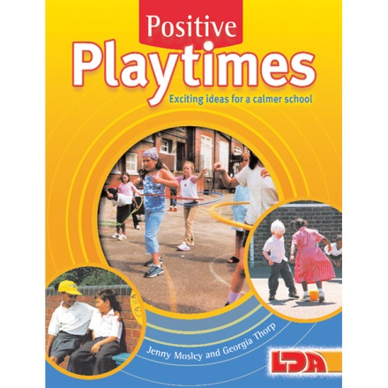

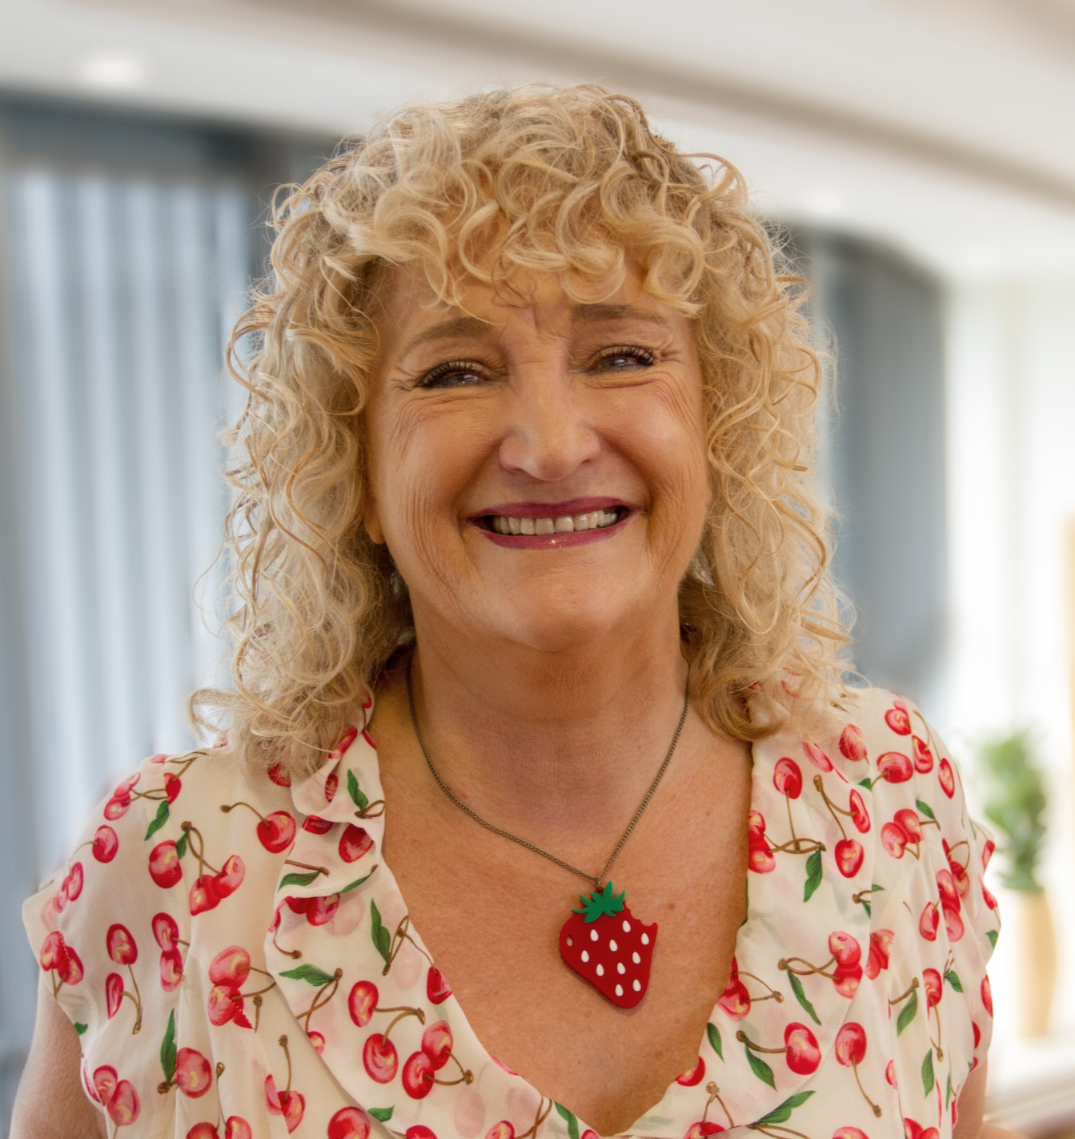

**PROMOTING EMOTIONAL HEALTH AND WELLBEING AND POSITIVE RELATIONSHIPS IN THE CLASSROOM, DINING HALL, PLAYGROUND AND STAFF ROOM**

**Tuesday 19th November 2019, 9.00am – 3.00pm**

**Ordiquhill School, Cornhill, Banff, Aberdeenshire, AB45 2EX**