

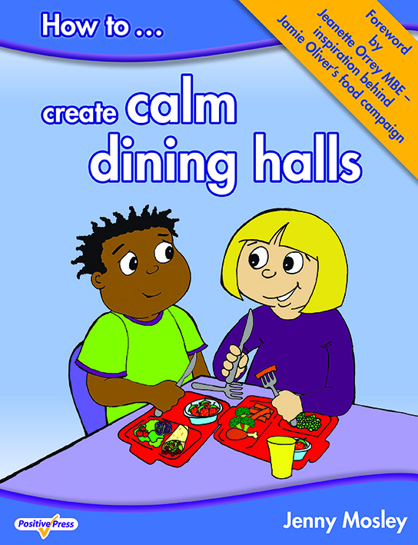
Friday 22nd May 2020
MORNING WORKSHOP FROM 8.45am – 11.30am

What is this training about?
Because Jenny is the leading pioneer of positive playtimes and the originator of zoning, playground friends and friendship stops – she will give many ideas to re-energise your playtimes. Jenny will highlight the importance of positive relationships and how these can motivate children to play well together and to relate well to mid-day supervisors and TAs. Delegates testify to the huge impact Jenny’s ideas have to revolutionise the dining hall systems and the ethos of the playground.

What past delegates say
“My head is buzzing with new ideas and I can’t wait to spread some joy! I would love everyone at my workplace to feel exactly the same as me! I feel absolutely motivated and how I felt when I first started this job 15 years ago! Mim Slater, TA, Northborough Primary School
“I have had wonderful feedback from not only my staff but other heads too who sent their staff on the training. All commented on your enthusiasm and inspiration. How wonderful is all of that.” Jennifer Richards, Headteacher, St Mark’s CE Primary, Bromley, Kent
“Please thank Jenny…she is truly inspirational. Playtimes are now much improved, and we are working on all the issues, having fun and playing lots……” Louise Siriwetchaphan, Pupil Support Worker, Beechwood Primary School, Leeds
Who is this day for? It is for lunchtime supervisors, teaching assistants and anyone who does lunchtime duties.
For a school to get the best value from the workshop Jenny encourages senior managers to attend so a true whole school dining hall and lunchtimes policy can be put in place.
Venue: St Peter’s Catholic Primary School, Dorset Avenue, Romford, RM1 4JA
Cost: £65 plus VAT per delegate.
To book a place: Please complete attached application form and fax back to 01225 755631 or email to joannap@jennymosley.co.uk or post to Jenny Mosley Consultancies, 28A Gloucester Road, Trowbridge, Wilts, BA14 0AA
If you have any questions please contact Joanna on 01225 767157
“Every part of the model has a positive impact on the school community and the successes achieved”
Fizz Starkey, ex Headteacher,NLE, SIP and Education Consultant

Course Trainer – Jenny Mosley
Jenny wrote the Happier Lunchtimes & Playtimes Guidance for the DfE’s Primary National Strategy, and was on the QCA’s PE and School Sports (PESS) steering committee to advocate traditional games in playgrounds! Her pioneering work in school playgrounds was featured on the BBC’s ‘Just One Chance’ programme. Jenny has written the first ever book on ‘How to Create Calm Dining Halls’ – it is packed full of tried and tested ideas and is incredibly practical. Find out how Jenny’s ideas Support British Values and the latest guidance from Ofsted.

Powerfully Positive Lunchtimes and Playtimes and Calm Dining Halls
Creating Calm , Positive ‘Social Times’ So Children and
Adults can Enjoy the Whole School Day
MORNING WORKSHOP – Friday 22nd May 2020 from 8.45am -11.30am
St Peter’s Catholic Primary School, Dorset Avenue, Romford, RM1 4JA

date

