The Importance of Attachment and Nurture
Attachment
‘Attachment Theory’ explains how a child interacts with the parents / carers looking after them. With healthy attachment, the child can be confident that adults will respond to their needs, for example if tired, hungry or frightened, the parent / carer responds to meet his needs or reassure and comfort him. This gives the child confidence to explore his environment and develop a good sense of self-esteem, helping to grow to be a happy, functioning adult.
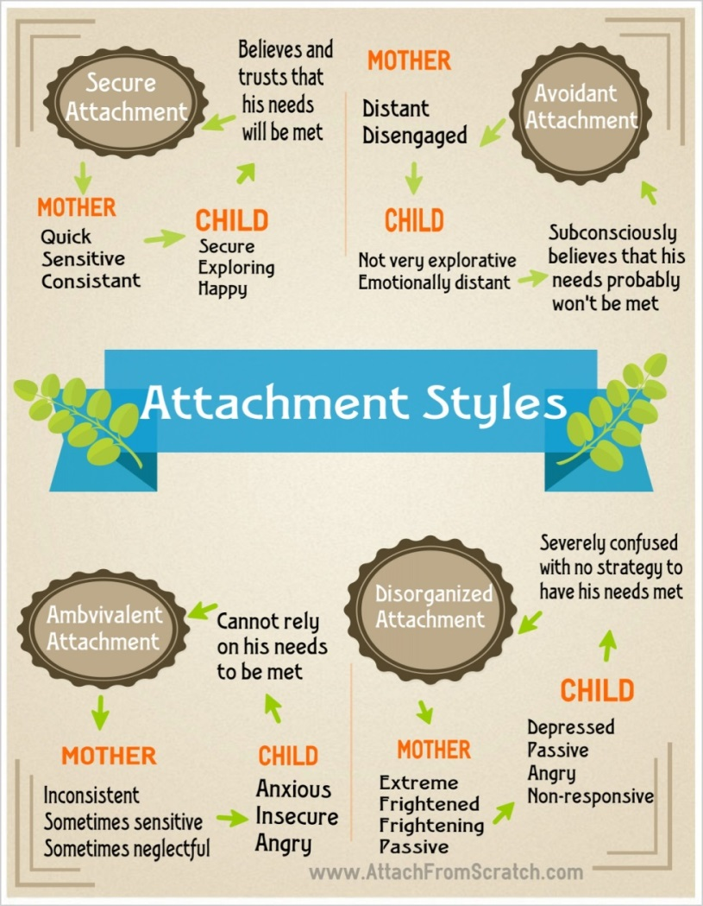
The Origins of Attachment Theory

Psychoanalyst John Bowlby developed a ‘theory of attachment’, further developed by Mary Ainsworth. Three main attachment styles have been described:
- Secure
- Insecure avoidant
- Insecure ambivalent.
- ‘disorganized’.
Most children are ‘secure’.

Nurture
The concept of nurture highlights the importance of social environments – who you’re with, and not who you’re born to – and its significant influence on social emotional skills, wellbeing and behaviour. It has been reported that children and young people who have an emotionally and physically healthy start in life are shown to have significant advantages over those who have experienced missing or distorted early attachments. They tend to do better at school, attend more regularly, form more meaningful friendships and are significantly less likely to offend or experience physical or mental health problems.
A nurturing approach offers a range of opportunities for children and young people to engage with missing early nurturing experiences, giving them the social and emotional skills to do well at school and with peers, develop their resilience and their capacity to deal more confidently with the trials and tribulations of life, for life.
(1of3)

Attachment Difficulties in Schools: What Might Happen, Why and How to Handle It In children who have experienced attachment difficulties in early life, their early, close relationship with their parents / carers did not provide sufficient nurturing for social, emotional and intellectual development to reach its full potential. This can make children:
- Feel negative about themselves (though this may be masked with bravado).
- Wary of others and pessimistic about the future.
- To have missed out on the development of crucial skills for life, particularly conscience development, social and friendship skills, the ability to control their emotions and their impulsiveness.
- Struggle to trust in any new, caring relationships.
Early adversity can affect brain development and therefore brain abilities that the child has. Skills such as cause and effect thinking, logical and abstract thinking, anticipation skills, memory, impulse control and emotion regulation may be affected. Consequently, a child may be unable to do as you ask, rather than deliberately not doing so.
We know that in nearly all instances, schools would like children to: | Children with attachment difficulties are coping with: | What might you see in school?  Child coping strategies
- Achieve their best.  - Work hard.  - Concentrate.  - Cooperate.  - Respect teachers.  - Be good to their peers. | - Fear of rejection or abandonment  - A survival instinct to be in control  - BUT a sense of helplessness  - Repeated losses, often sudden and unexpected.  - A need to please but a need to pretend they don’t care  - A mix of levels for each aspect of development  - Frequent overwhelming emotions – panic, rage, grief, excitement  - Constantly checking their environment for danger; focussing on feeling safe. | - being over-anxious to please  - acting out their chaotic feelings  - being very withdrawn  - sometimes shifting between strategies – acting in one way with some people and another way with others, leading to confusion of the staff  (2of3)

Behaviours of Particular Concern
Some behaviours, of more particular concern to staff can include:
- Poor concentration
- Disruptive behaviour
- Constantly asking trivial questions – perfectionism
- Difficulties coping with change
- Ignoring instructions
- In trouble at break times
- Crating chaos and mayhem
- Refusal to be helpful
- Lying stealing, fighting or hurting other children
- ‘Explosions’ around certain work
- Sudden rages or tantrums
- Difficult attitude, defiance, refusal, disrespect to teachers
- Class comedian
- Running away or hiding
- Behaviour suddenly deteriorates
What Schools Can Do To Support All Children
- Provide calm, structured supervision as much as possible, teachers setting the tone of the class rather than the children.
- Think for the children when necessary.
- Think ‘toddler’ when the child is acting like they are emotionally immature like a toddler.
- Remember ‘teaching’ not punishing – these children are often lacking in skills rather than disobeying.
- Give small amounts of attention frequently – to let the child know you are attending to them during lessons.
- Try to show them you are listening, and validate their feelings when possible.
- Have a scheme that allows them some cool-down time.
- Think about seating plans – where would be most secure?
- Explain any changes in timetable, staff, activities.
- Think carefully about class references to family, or activities around family and use.
- Use short-term choices and consequences – not a long timescale for rewards, sanctions and threats.
- Use creative arts – many children will excel at this – it will help the child to express themselves.

(3of3)

