E te Kaha Rawa, nōu te puna waiora o tātou katoa, tēnā koe.
Ki a koutou ngā mate huhua o tēnā iwi o tēnā iwi puta noa i te ao, whai atu rā koutou i ngā takahanga waewae o ō tātou kāwai rangatira ki te okiokinga tuturu o koutou, e moe.
Ka huri atu ki i a tātou ngā mahuetanga e hāpai tonu ana i ngā wawatā o rātou mā, nei rā te mihi aroha ki a tātou katoa.
Ki a koutou te whānau o Te Kura Kaupapa Māori O Te Rito me Te Kura Kaupapa Māori O Manawatū, ki te kore koutou e kauawhiawhi i te kaupapa nei, kāhore te kaupapa e whaitake ana mō a tātou tamariki mokopuna, no reira, kei te mihi.
Tēnei a Te Whiri Kōkō te tuku mihi nei ki a koe Jenny. Ko koe te rangatira e kaha whāngai atu i tō kaupapa ki ngā tamariki me ngā kaiako o te ao.
No reira, tēnā koe Whāea, otira tēnā tātou katoa.

Tēnā koe Jenny,
Te Whiri Kōkō is a group of specialist teachers (Resource Teachers of Learning and Behaviour – RTLB). Our cluster provides support and guidance to teachers working in primary and secondary schools across five districts. In our work catchment area, we also have six Māori iwi (tribes): Ngāti Kahungunu, Rangitāne, Muaupoko, Te Ati Awa, Ngāti Raukawa and Ngāti Toa Rangatira whose input into the curriculum, language and tikanga (protocols) in our Māori medium education settings is highly valued. There are three RTLB who work in our five total immersion Māori language schools. All but one of these is an area school, meaning that their students are in the primary and secondary sectors.
In 2016, I had the privilege of attending one of your four-day workshops titled Training the Trainer Quality Circle Time. It was an amazing four days filled with lots of learning and of course, golden moments!
Since this workshop, the interest in Quality Circle Time has grown considerably in Te Whiri Kōkō. We have provided support for other RTLB through basic training and we support other RTLB who are using Quality Circle Time in their casework. We have implemented the Quality Circle Time programme in classrooms, and we continue to support schools who want to take this on as a whole school approach through facilitation of professional development for teachers and a robust plan of support. This means that we work with teachers in their classes for approximately six weeks.
Since 2016, many of our mainstream schools embraced Quality Circle Time and are now implementing it regularly into their classrooms and schools. In 2018 our Māori schools were starting to show an interest. Māori RTLB staff held two hui (meetings) with teachers who work in total immersion Māori schools. We discussed various items of relevance including a range of programmes. The teachers of one of the schools was very keen to give Quality Circle Time a try. Also, around this time, I was noticing that a lot of my referrals from the three Kura (school) Kaupapa Māori I was working in, were requesting support with teaching students appropriate behaviour, minor conflict resolution and strategies to calm self and to manage emotions. I targeted one of the Kura Kaupapa Māori because they had a lot of behaviour referrals for individual students and classes, compared to my other two kura who had very few. These two situations provided the catalyst we needed to take Quality Circle Time to other Kura Kaupapa Māori.
A lot of our discussions with teachers were about how Quality Circle time aligns with many of the principles of Te Aho Matua which is a Māori philosophy that Kura Kaupapa Māori follow. We identified areas of the programme that sit well in a Māori cultural framework and the areas we needed to adapt to ensure its relevance in a Māori setting. Teachers became enthused when they could see Quality Circle time as not only an effective intervention for meeting the needs of their tamariki (children), but also one that could align to tikanga Māori, (protocols) and Māori values and fit a Māori cultural context as well as their school context.
We wrote a professional development plan for both school staff, considering the unique needs of each school. The plan included one staff meeting session followed by demonstrations in classes and ongoing support for teachers after that.
The most obvious change we made was in the language. We translated a lot of material including the whole school Quality Circle Time model. We changed the name to Huinga Tauawhiawhi for one of our schools as the name reflects a piece of their history, but it is also an appropriate name for Quality Circle Time in other schools. The photos below will expand on some of the changes as well as show you just how well Quality Circle Time is received by our kaiako (teachers) and our tamariki (students). In 2019 RTLB delivered a session on Quality Circle Time at our national Māori RTLB annual hui (meeting).
Quality Circle Time is very much an active component of the RTLB work in our cluster.
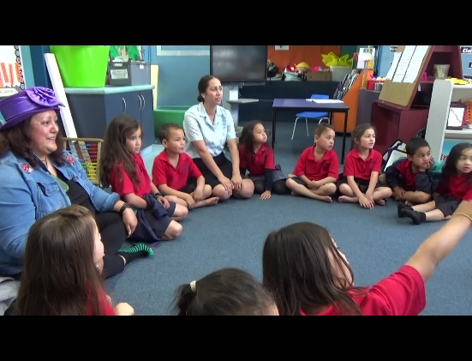
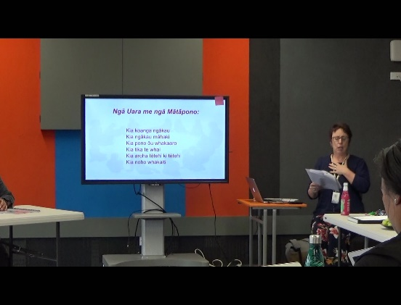
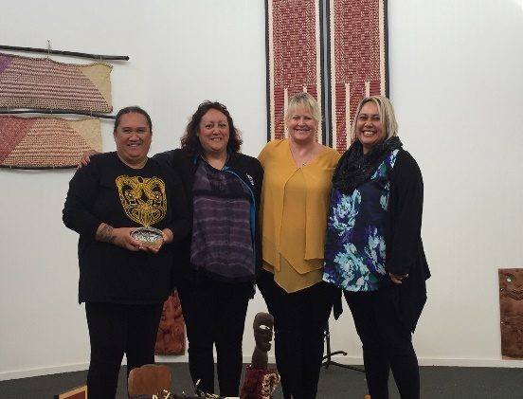
We prefer to sit on the floor when we work with our tamariki because we are closer to Papatūānuku (Our earth mother).
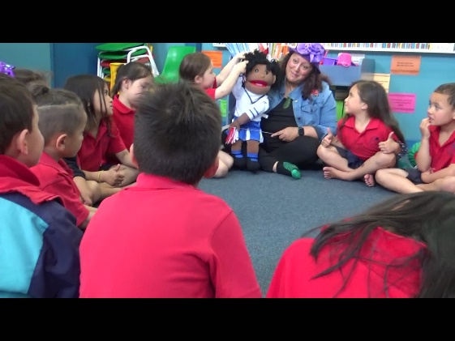
It is important that tamariki are able to see themselves reflected in the resources used to teach them. This is Pare and the tamariki love her.

Our team: Mereana, Te Amokura, Margaret, Tracey & Andrea
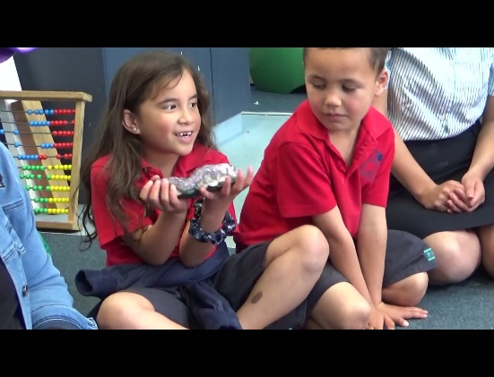
Instead of a talking egg we have something that is heavy and from the earth to keep us grounded. We call this a mauri. It is tikanga in our culture that as much as is possible, we follow the mauri of the kōrero, meaning that we go around the circle in order of where we are sitting to speak rather than flit from one side of the circle to the other and back again. I use an amythest and his name is Rangi-naonao-ariki which is one of the 12 heavens (rangi tūhāhā). It is also the Māori term for the crown chakra.

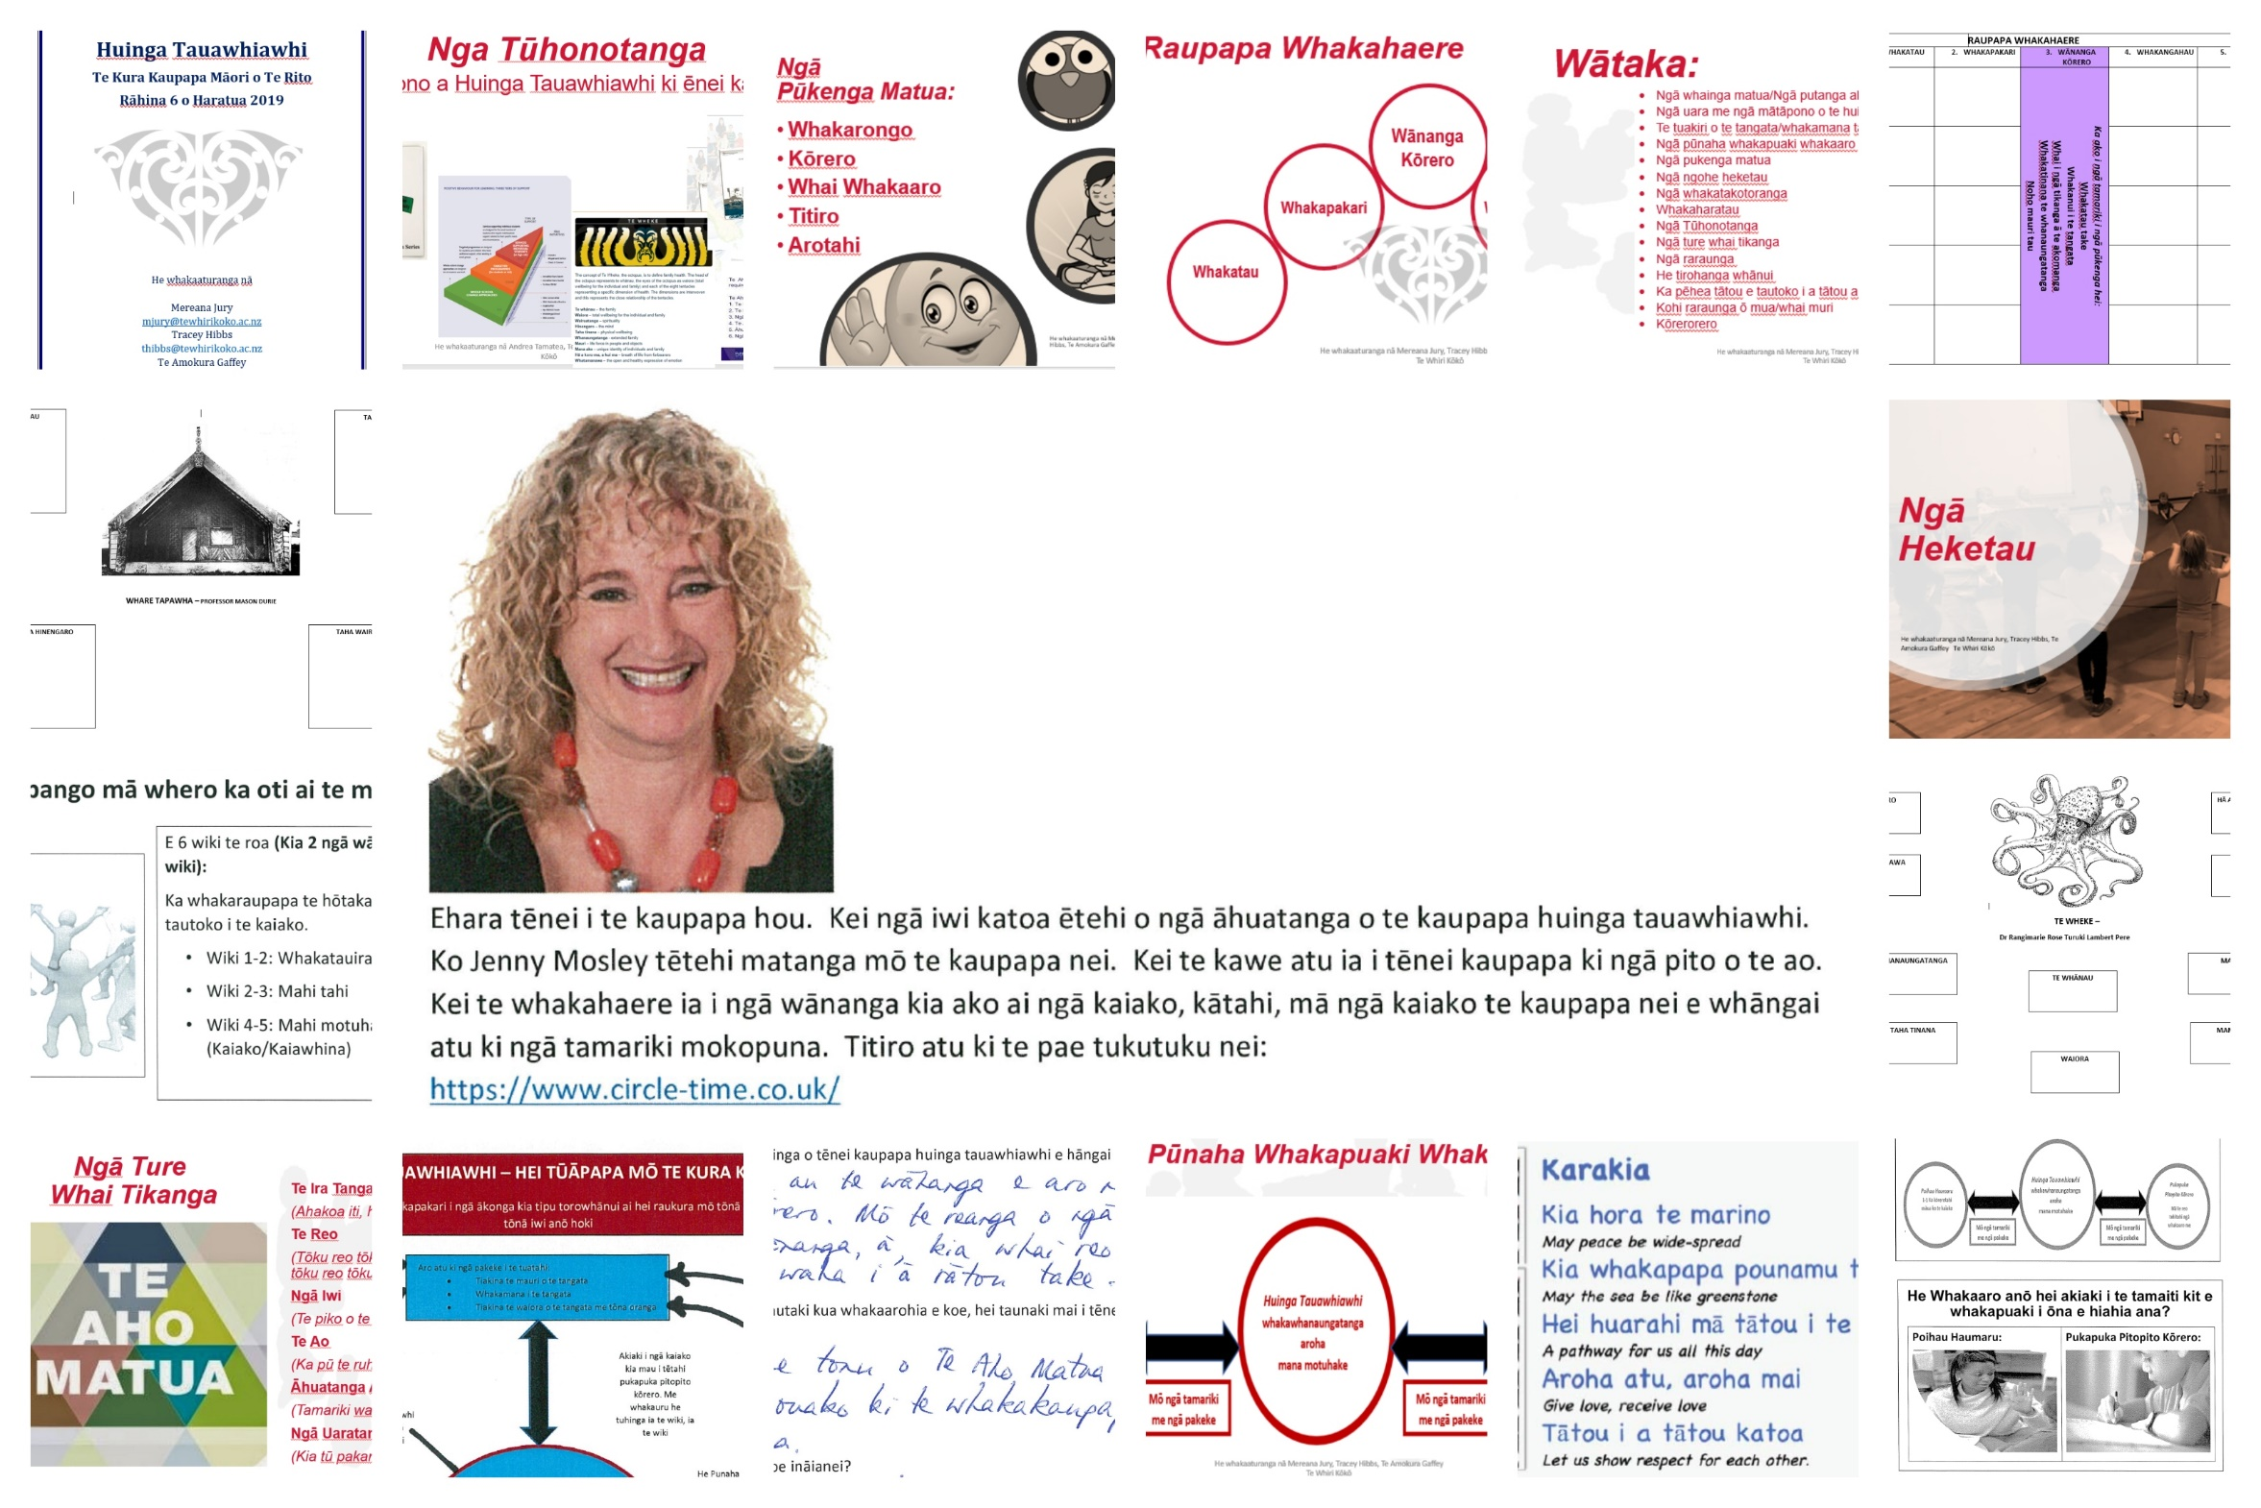

It is important to translate all resources into Māori, not only for the tamariki, but also for the younger teachers who grew up in Kura Kaupapa Māori because they do not think in English like those of us who learned to speak Māori as adults. It is also important to find the common links between Jenny Mosley’s Quality Circle Time and Māori aspirations and values. Huinga Tauawhiawhi (QCT) can naturally flow from the morning karakia session as these sorts of hui are often opened and closed with karakia, (karakia are a little bit like prayers). Māori games and whakatauki (like proverbs) can be used as well as waiata (songs).

